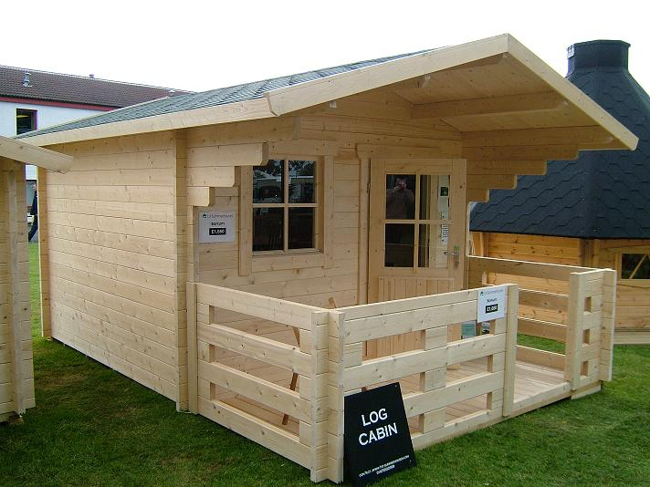 | 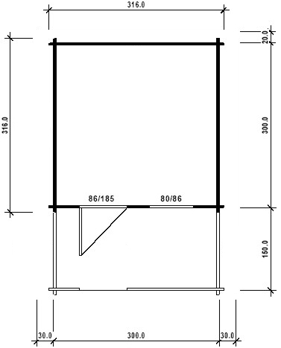
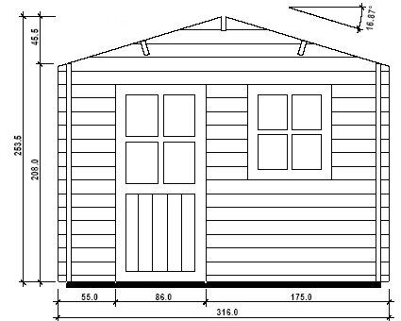

3m x 3m Borkum
Roof projection: Front 1.5 m
Back 0.2m
Side 0.3m

Consists of:
Walls: 45 mm double tongue and groove logs from Northern Pine
Floor: 20 mm tongue and groove floor boards on the impregnated base frame
Terrace: 1.5 x 3.0 m
Roof: 20 mm tongue and groove roof boards on the roof beams
Door: 1 half-glazed door 86/185
Windows: 1 80/86 tilt ‘n‘ turn unit

Size (m) | Price | Optional Extras  Shingles
3 x 3 | £1,660 | £150

